CBDAS

2310030428
V Lakshmi Prasanna

1 . Create two S3 buckets and delete the same using AWS CLI

Step 1: Install the aws cli
Step 2: After installing go to command prompt in our system.
Type

aws –version
It will show the the version of aws and confirms the whether the aws is downloaded or not.
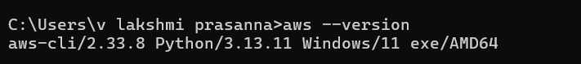

Step 3: Give Acess key and secret key Type

aws configure
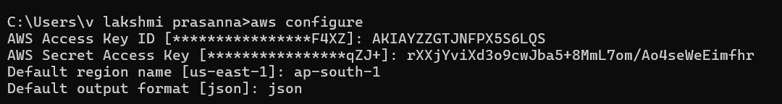

Step 4: Create 2 buckets in S3 in that same command prompt First bucket name: aws s3 mb s3://lakshmi-bucket-001
Second bucket name: aws s3 mb s3://lakshmi-bucket-002
Type

aws s3 mb s3://lakshmi-bucket-001

aws s3 mb s3://lakshmi-bucket-002
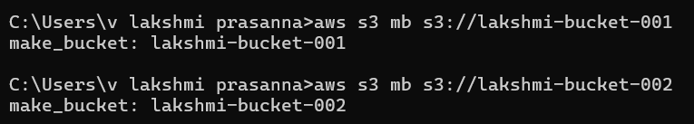

Step 5: The bucket are now created and listed in S3 . Type

aws s3 ls
This will help in listing all the buckets in the S3
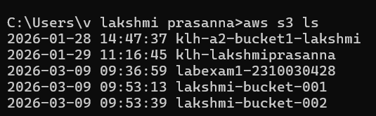

Here we can see the 2 buckets name in the above pic

Step 6: Now we have to delete the 2 buckets Write

aws s3 rb s3://lakshmi-bucket-001 –force
aws s3 rb s3://lakshmi-bucket-002 --force

Step 7: To check wether the buckets deleted or not Type

aws s3 ls
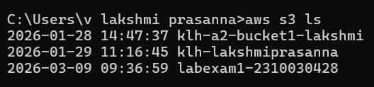

From the above pic we can confirm that the
First bucket name: lakshmi-bucket-001
Second bucket name: lakshmi-bucket-002
are deleted in the s3.

